**KING HAMIRI EDUCATION CENTER ARUA**

PRE-PLE Social studies marking guide 2022

**SECTION A: 40 MARKS**

1. Name any **one** animal kept at home to provide labour.
   * + - **Horse** • **Camel**
       - **Donkey** • **Oxen**
2. State **one** role of a Local Council Chairperson in our village.
   * + - **To settle conflicts**
       - **To promote peace and security**
       - **To implement government programs**
       - **To monitor government programs**
3. How can people in your community improve on their incomes?
   * + - **Through farming** • **Through accessing loans**
       - **Through saving resources** • **Through tailoring**
       - **Through fishing** • **Through teaching**
       - **Through trade**
4. Name the Bantu tribe in South Africa that was much affected by the Great Trek.

• **The Xhosa.**

1. Why is the government dividing Uganda into small administrative units?
   * + - **To ease administration**
       - **To ease delivery of social services**
       - **To control rural urban migration**
       - **To promote development**
       - **To create employment opportunities**
2. Give any **one** danger created by the use of mobile phones in our country.
   * + - **High rate of immorality/antisocial behavior**
       - **Laziness** • **Domestic violence**
       - **Cyber bullying** • **Addiction**
       - **Accident**
       - **Decrease social / communication skills**
       - **Increase the rate of terrorism**
       - **Increase the rate of poverty**
3. How are the monsoon winds useful to farmers?

• **The South East Monsoon winds bring rainfall in East Africa and equatorial region which water farmers crops to grow well.**

1. Name any **one** African country that lies in the Eastern and Western hemisphere.
   * + - **Ghana** • **Burkina Faso**
       - **Algeria - Togo.** • **Mali**
2. How is Addis Ababa an important town to the African Union?
   * + - **It hosts the headquarters of the African union**
       - **It is where the main seat of the African Union is found**
3. Mention **one** way in which industrial growth is a danger to people around.
   * + - **It increases pollution ( air, land, noise and water pollution)**
       - **It leads to land grabbing due to increased population**
       - **Leads to high population**
       - **Leads to poor sanitation**
       - **Leads to poor housing near factories**
       - **Leads to creation of slums**
4. Give any **one** factor that a trader considers before deciding on the type of transport to use to transport his goods.
   * + - **Type of weather** • **The cost of transport**
       - **Type of goods** • **The quantity of goods**
       - **The distance to destination**
       - **The comfortability of means of transport**
       - **Nature of land scape**
       - **Speed of the means of transport.** • **Affordability**
       - **Availability of transport means.** • **Accessibility.**

Study the sketch map of Uganda below and use it to answer questions **12** and **13**.

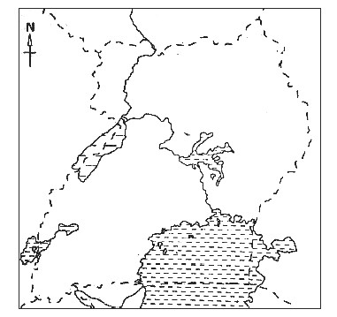

**Town C**

**A**

**Town B**

1. Name the feature marked **A** on the map.

• **Karuma dam**

1. If town **B** is 6 cm from town **C**, find the actual ground distance between the two places given that 1cm:50km.

**1cm = 50km**

**6cm = 6×50km**

**= 300km**

1. Write **one** reason why a child is given a name.
   * + - **It is a right to have a name.**
       - **To promote culture.**
       - **For easy identification.**
       - **To fit in the community.**
2. Name any **one** lake in the Western arm of the East African rift valley.
   * + - **Lake Kivu** • **Lake Katwe**
       - **Lake Edward** • **Lake Tanganyika**
       - **Lake Albert** • **Lake George**
3. How did Johann Ludwig Krapf help the coastal people to understand the the Bible?
   * + - **He translated the New Testament from English to Kiswahili.**
       - **He taught people how to read and write**
4. Give **one** way slave trade affected the economy of some African states. • **It retarded economic activities like agriculture since strong people who would carry out farming were taken as slaves.** • **It led to shortage of labour.**
5. How do people living in Sahara desert guard themselves against the sun’s heat?
   * + - **They put on sun glasses** • **They bathe regularly**
       - **They put on light clothes** • **They put on turbans** • **They use air conditioners** • **They take hot drinks**
6. Give any **one** effect of the rotation of the earth on its axis.
   * + - **Causes movement of shadows**
       - **Day and night** • **Time differences**
       - **Ocean currents** • **Wind movement**
       - **Tides (waves)**
       - **The rising and setting of the sun proves that the sun rotates on its axis day and night.**

The diagram below shows Mr. Okumu’s house. Study and use it to answer questions **20** and **21**.

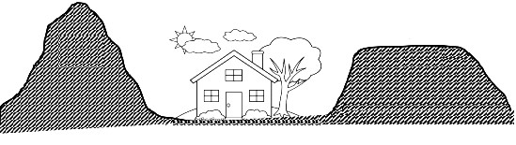

**B**

1. State **one** problem that will affect Mr.Okumu and his house.
   * + - **Floods**
       - **Landslide/ mudslide**
2. How is physical feature marked **B** useful to people?
   * + - **It promotes tourism**
       - **It is a source of minerals**
       - **Helps in rain formation (relief rainfall)**
       - **Has fertile soil for cultivation**
       - **Provides space for setting up telecommunication masts**
3. How do plants in equatorial region adopt to climatic conditions? • **They grow tall to compete for sunlight**

• **They are evergreen due to plenty of rainfall received**

1. Name the horst mountain found in Uganda. • **Mount Rwenzori.**
2. In which **one** way was the coming of missionaries a blessing to the people of East Africa?
   * + - **Missionaries introduced new crops**
       - **They built schools**
       - **They built hospitals**
       - **They built churches**
       - **They stopped slave trade**
       - **They introduced new farming methods**
       - **They treated different diseases (sleeping sickness)**
       - **They built roads**
       - **They taught people reading, writing and arithmetic.** • **They introduced Christianity.**
3. Why are most district headquarters located near major towns and roads?
   * + - **To ease administration.**
       - **For easy delivery of services.** • **There is a big population.**
4. Give **one** reason why the government discourages human settlement in and around game parks.
   * + - **To prevent people from being attacked by wild animals**
       - **To prevent people's crops from being destroyed by wild animals** • **To prevent poaching**
       - **To prevent encroachment.** • **To conserve wildlife.**
5. Name the type of vegetation that usually has plants of the same species. • **Planted vegetation.**

1. Apart from handling imports and exports, state any **one** other economic importance of ports to a country.
   * + - **They generate income through tourism**
       - **They are major commercial centres**
       - **They are sources of taxes**
       - **They are recreation centers**
       - **They promote investment**
       - **They promote industrialization**
2. Mention any **one** effect of swamp drainage to animals.
   * + - **Leads to destruction of animal habitats**
       - **Leads to destruction of vegetation**
       - **Leads to death of animals**
       - **Leads to shortage of pasture**
       - **Leads to shortage of water**
3. State any **one** cause of differences in climatic conditions experienced in different parts of Uganda.
   * + - **Vegetation distribution** • **Altitude**
       - **Prevailing winds** • **Latitude**
       - **Relief** • **Land and sea breezes**
4. What title is given to a person who heads all civil servants in a Municipality? • **Clerk /Town clerk**
5. Why should children be taught about child abuse?
   * + - **To know their rights**
       - **To defend their rights**
       - **To know where to report in case they are abused.**
       - **To promote peace and security**
       - **To identify and report child abusers**
6. Give any **one** way people mark boundaries of their land.
   * + - **Planting trees/hedge**
       - **By building a fence**
7. State any **one** role that was played by political parties in the struggle for independence of their countries.
   * + - **They united people**
       - **They advocated for human rights**

1. 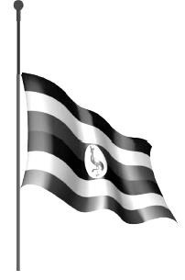Give **one** reason for raising the Uganda National flag as shown in the diagram below.

* + - * **To show a national mourning**
      * **To show that the country has been hit by a natural disaster**

For each of the questions **36** to **40**, answer **Either** the Christian **OR** Islamic questions but **not** both. No **marks** will be awarded to a candidate who attempts both alternatives in **a particular number**.

1. **EITHER:**

In which town was Jesus Christ burried?

* + - * **Jerusalem**

**OR:**

In which town was Prophet Muhammad buried?

* + - * **Medina**

1. **EITHER:**

Who is regarded as the last prophet according to Christianity? • **John the Baptist**

**OR:**

Who is regarded as the last prophet according to Islam?

• **Prophet Muhammad**

1. **EITHER:**

Give any **one** way a Christian can keep away from evil.

* + - * **By fasting**
      * **By reading the Bible**
      * **By praying**
      * **By preaching the gospel**
      * **By attending church services**
      * **By participating in co-curricular activities.** • **Avoiding tempting places.**

**OR:**

Give any **one** way a Muslim can keep away from evil.

* + - * **By fasting**
      * **By reading the Quran**
      * **By praying**
      * **By preaching Islam** • **By attending Juma prayers.**

1. **EITHER:**

Mention any **one** way poverty can make a Christian sin to God.

* + - * **It leads to theft** • **It leads to child abuse**
      * **It leads to suicide** • **It leads to witchcraft**
      * **It leads to prostitution**
      * **It leads to homosexuality and lesbianism**
      * **It leads to hatred, envy and jealousy**

**OR:**

Mention any **one** way poverty can make a Muslim sin to God. • **As above**

1. **EITHER:**

Mention **one** category of books in the Bible.

* + - * **Torah / law books/ Pentateuch**
      * **Historical books** • **Wisdom books**
      * **Poetic books** • **Prophetic books** • **The Gospels** • **Epistles/ letters**

**OR:**

Mention **one** division of the Quran.

* + - * **Juzzu.** • **Surah (Chapter)**
      * **Ayyat (Verse)**

**SECTION B: 60 MARKS**

1. a) Name the body in Uganda responsible for registering telephone companies.

• **Uganda Communications Commission (UCC)**

b) Mention any **two** ways Ugandans have benefited from the registered telephone companies.

**They have got jobs**

**They have eased communication**

**They have got taxes**

**They have advertised goods using telephones**

**It has eased banking**

**They have eased security services**

c) Give any **one** advantage of using a telephone over newspapers to send messages.

• **A telephone is faster than a newspaper**

1. a) Mention **one** factor that determines the settlement position of ethnic groups.

**Climate** • **Water bodies**

**Nature of the soil** • **Vegetation**

**Weakness of the inhabitants**

* + 1. What was the first ethnic group to migrate into East Africa? • **The Cushites/Hamites**
    2. State any **one** way of identifying an ethnic group.

**By following their major occupation**

**By following their Origin** • **Cultural practices**

**Language** • **Cultural institution**

d) Name any **one** Bantu tribe that is settled on the slopes of Mount Kilimanjaro.

**The Chagga.**

**The Kisi.**

1. a) State any **two** advantages of multiparty system of administration.

**Promotes democracy**

**It control dictatorship**

**There is delegation of power**

**There is room to choose better leaders**

* 1. Why is political stability good for a country?

**It promotes development**

**It promotes investment**

**It promotes trade**

**It promotes friendship and cooperation**

* 1. How are many bye-elections a disadvantage to a country?

• **They lead to high government expenditures.**

1. Study the sketch map of East Africa below and use it to answer the questions that follow.

**2**

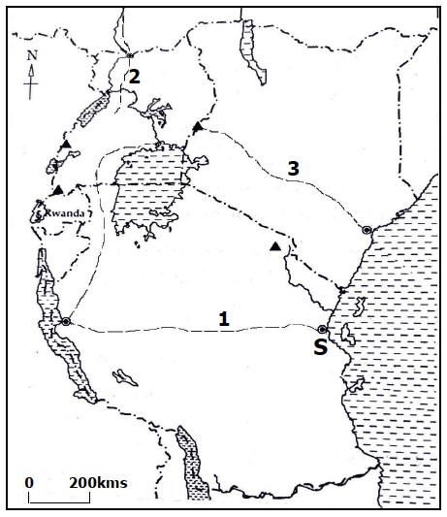

a) Name one European explorer that used routes marked **1** and **2**.

i)  **1** - **John Speke / James Grant / Henry Morton Stanley**  ii)  **2 - Sir Samuel Baker**

* 1. Name town marked with letter **S**.

• **Bagamoyo**

* 1. State any **one** reason why most European explorers did not use

route marked **3** while entering the interior of East Africa.

* + - * + **They feared attacks from hostile tribes** • **It was far from Zanzibar.**
        + **Route 3 had fierce animals** • **Tanganyika had clear routes.**
        + **Route 3 had harsh climatic conditions.**

1. a) Give any **one** symbol of a clan.
   * + - * **Drumming** • **Totem**
         * **Royal regalia like stools, crown, throne, spear etc.**
         * **Clan leader** • **Clan name**

* 1. Apart from clans, name any **one** other social set up of people in the pre-colonial times.
     + - * **Had families** • **Had age setups**
         * **Had lineage** • **Had religious beliefs**
         * **Had traditional education**
  2. State any **two** ways family meetings promote unity.
     + - * **They help to settle family disputes**
         * **They promote reconciliation**
         * **They promote family values**
         * **They bring family members together**

1. The table below shows multi-purpose river projects with rivers on which they were built in different countries of Africa. Study and complete it correctly.

|  |  |  |
| --- | --- | --- |
| **River** | **Dam** | **Country** |
| River Nile | Isimba dam | (i) **Uganda** |
| (ii) **Zambezi** | Kariba dam | (iii) **Zambia ,**  **Zimbabwe** |
| River Niger | (iv) **Kainji dam** | Nigeria |

1. a) Name the specialized Agency of United Nations that fights the outbreak of pandemic diseases.

• **World Health Organization (WHO)**

b) Give **one** way the United Nations similar to Commonwealth of Nations in their works.

* + - * + **Both promote respect for human rights**
        + **Both strengthen relationship with African countries** • **Both struggle to end poverty in African countries** • **Both promote peace.**
        + **Both aim at promoting peace and security in member states** • **Both promote education through encouraging open and**

**distance learning programmes**

* + - * + **Both promote democracy and development**

c) Which Agency of United Nations ensures that people displaced by wars are catered for?

• **United Nations High Commissioner for Refugees (UNHCR)**

d) How did Rwanda become a member of Commonwealth of Nations yet it was not colonized by Britain?

• **Through application.**

1. a) What is plantation farming?

• **Plantation farming is the growing of one perennial crop on a large piece of land.**

* 1. Mention **one** scheme in Africa where the following plantation crops are grown on a large scale.

i) Cotton:  **Gezira irrigation scheme , Managil** ii) Sugarcane: **Kilombero valley, Kenana**

* 1. Give **one** reason why plantation farming is not common in densely populated areas.

• **Due to shortage of land // Needs a large piece of land which is usually not available in densely populated areas.**

1. Study the sketch map Africa below and then answer the questions that follow.

**Q**

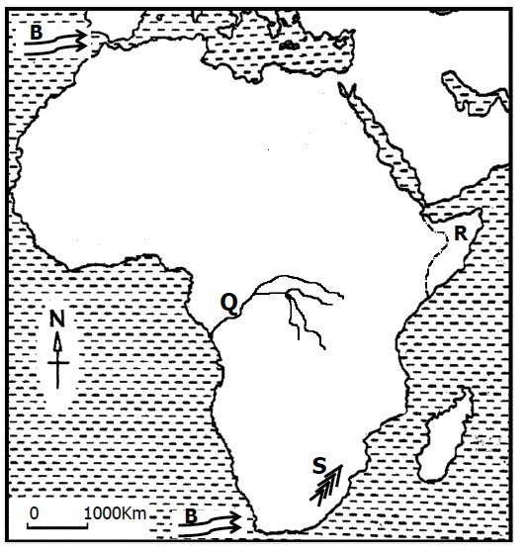

* 1. Name the winds marked with letter **B**. • **Westerly winds // Westerlies.**
  2. How were highlands marked **S** formed? •  **Volcanicity**
  3. Write down any **one** social problem faced by country marked **R**.
     + - * **Famine** • **Illiteracy**
         * **Diseases** •  **Disunity**
         * **Early marriages (high Birth rates) - Civil wars.**
         * **High infant mortality rate**
         * **Low life expectancy**

d) How does river marked **Q** affect the transport network in DRC? • **It floods during rainy season blocking means of road transport.**

• **Makes road construction difficult.**

1. a) Name any **one** illegal practice that reduces on government revenue.
   * + - * **Smuggling** • **Tax defaulting/ evasions**
         * **Corruption** •  **Black marketing**
         * **Poaching**
   1. State any **two** negative effects of illegal trade to a country.
      * + - **It lowers government revenue**
          - **Leads to poor delivery of social services** • **Leafs to under development**
   2. Give **one** reason why a country should fight against illegal trade.
      * + - **To increase tax collection/ government revenue**
          - **To end trading of expired goods are sold**
          - **Leads to improvement**

For each of the questions **51** to **55**, answer **EITHER** the Christian **OR** Islamic questions but **not** both. **No mark** will be awarded to a candidate who attempts both alternatives in **a particular number**.

1. **EITHER:**

a) How is a priest important during church service?

* + - * + **He leads prayers** • **He guides and counsels people**
        + **He prays for people** • **He preaches the word of God** • **He conducts sacraments** • **He preaches reconciliation**

b) Mention any **two** groups of people a Christian can pray for.

|  |  |
| --- | --- |
| * **The sick** * **The poor** * **The blind** * **The elderly** * **The candidates** * **The lame** * **The Babies** | * **The leaders** * **The street children** * **The orphans** * **The refugees** * **The prisoners** * **The travelers** * **The security officers** |

• **The pregnant women**

c) Name the type of prayer a Christian child who has excelled in exams says. • **Thanks giving prayer**  **OR:**

a) How is an Imam important during Jumah prayers?

* + - * + **He leads prayers. - Delivers the Friday sermon.**
        + **He prays for people**
        + **He guides and counsels people** • **He preaches the word of Allah**
        + **He teaches reconciliation**

b) Mention any **two** groups of people a Muslim can pray for.

|  |  |
| --- | --- |
| * **The sick** * **The poor** * **The blind** * **The elderly** * **The candidates** * **The lame** * **The Babies** | * **The leaders** * **The street children** * **The orphans** * **The refugees** * **The prisoners** * **The travelers** * **The security officers** |

• **The pregnant women**

c) Name the first daily prayer in Islam.

• **Fajr/Subhi**

1. **EITHER:** 
   * 1. Name the world religions whose symbols are drawn below.

|  |  |
| --- | --- |
|  |  |
| **Judaism** | **Christianity** |

* + 1. Who is the founder of the religion whose symbol is drawn in no.52a(i)?

• **Abraham**

c) Give **one** importance of religious symbols to believers. • **Help believers to deeply understand their faith** • **Strengthens a believer’s faith.**

* + - * + **They help them to share some common beliefs**
        + **For easy identification**
        + **They promote unity**

**OR:**

* + 1. Name the Islamic symbols drawn below.

|  |  |
| --- | --- |
|  |  |
| **Star** | **Crescent** |

* + 1. Give any importance of Islamic symbols to believers. • **Help believers to deeply understand their faith** • **Strengthens a believer’s faith.** 
       - * **They help them to share some common beliefs**
         * **For easy identification -They promote unity**

1. **EITHER:**

‘‘I baptize you with water to show that you have repented but the one who will come after me will baptize you with Holy Spirit and fire.’’ (Matthew: 3:11)

* 1. Who preached the above message? • **John the Baptist**
  2. Who will baptize with the Holy Spirit and fire according to the message? • **Jesus Christ**
  3. What is the importance of water during baptism?

• **Washes away the original sin // Used as a cleanser.** • **Acts as a sign of purity.**

d) Mention **one** lesson you learn from the above message.

* + - * + **To get baptized** • **To repent**
        + **To welcome the holy spirit** • **To be God fearing** • **To accept Jesus Christ**

**OR:**

‘‘……..they shall bear their own loads and others loads besides their own.

And they will surely be questioned on the Day of Resurrection about what

they used to invent’’ (Quran: 29:13)

a) Mention any **two** forms of punishments that will be given to

non-believers according to the above Quran text.

* + - * + **Being thrown in eternal fire.**
        + **Denial of blessings.** • **Curse.**
  1. What will happen to the non-believers on the day of judgement

according to Islamic teachings?

• **They shall be questioned for what they invented** • **They will have everlasting suffering in hell.**

* 1. What lesson do you learn from the above Quran verse?
     + - * **To repent our sins** • **To be faithful**
         * **We shall be accountable for our sins.**
         * **To prepare for the day of resurrection**
         * **To follow Allah's teaching**

1. **EITHER:**

a) What are relief organizations?

* + - * + **These are organisations that provide assistance to people in need**

b) Mention any **two** Christian relief organizations operating in Uganda.

* + - * + **ADRA Adventist Development Relief Agency**
        + **Christian Relief Uganda** • **Christian Aid Mission in Uganda**
        + **The Catholic Relief Service** • **Child of Hope**
        + **Joint Relief Agency** • **Smile Charity Uganda**

c) Write any **one** way how relief organizations promote development in Uganda.

* + - * + **They employ people** • **They set up banks**
        + **They build school** • **They set up radio station**
        + **They build hospital** • **They set up TV station**
        + **They set up social service centers**

**OR:**

a) What are relief organizations?

• **These are organisations that provide assistance to people in need especially affected by disasters**

b) Mention any **two** Islamic relief organizations operating in Uganda

* + - * + **Islamic Relief Worldwide** • **Islamic Relief Organisation**
        + **Islamic Relief** • **Salaam Charity**
        + **International Islamic Relief Organisation (IIRO)**

c) Write any **one** way how relief organizations promote development in Uganda.

• **As above**

1. **EITHER:**

a) How is helping one another useful in Christian life?

|  |  |
| --- | --- |
| * **It promotes peace** * **It promotes unity** * **He ate with sinners** * **It promotes friendship** | * **It promotes hardworking** * **One gets blessings from God** * **You get respect** * **One gets security** |

• **It promotes love**

* 1. Give **two** ways how Jesus showed concern over his followers.

|  |  |
| --- | --- |
| * **He prayed for his followers** * **He healed the sick** * **He died for their sins** * **He washed the apostles feet** | * **He fed the hungry** * **He made the blind to see** * **He healed the lame** * **He forgave the sinners** |

• **He raised the dead**

* 1. What lesson do we learn from Jesus’ concern?
     + - * **To pray for others**
         * **To forgive others**
         * **To feed the hungry**
         * **To share**
         * **To heal the sick**
         * **To love everyone**

**OR:**

a) How is helping one another useful in Islamic life?

|  |  |
| --- | --- |
| * **It promotes peace** * **It promotes unity** * **He ate with sinners** * **It promotes friendship** | * **It promotes hardworking** * **One gets blessings from God** * **You get respect** * **One gets security** |

• **It promotes love**

b) Give **two** ways how Prophet Muhammad (PBUH) showed concern over his followers.

* + - * + **He prayed for his followers**
        + **He healed the sick**
        + **He fed the hungry** • **He forgave the sinners**
        + **He grazed their animals.** • **He kept their property.**

c) What lesson do we learn from Prophet Muhammad’s concern?

* + - * + **To pray for others**
        + **To forgive others**
        + **To feed the hungry**
        + **To share**
        + **To heal the sick**
        + **To love everyone.**